# Rossmoyne Senior High School

### Semester One Examination, 2015

### Question/Answer Booklet

**SOLUTIONS**

# MATHEMATICS APPLICATIONS

# UNIT 1

## Section Two:

## Calculator-assumed

|  |  |  |  |  |  |  |  |  |
| --- | --- | --- | --- | --- | --- | --- | --- | --- |
| Student Number: In figures |  |  |  |  |  |  |  |  |

In words

Your name

## Time allowed for this section

Reading time before commencing work: ten minutes

Working time for this section: one hundred minutes

## Materials required/recommended for this section

##### *To be provided by the supervisor*

This Question/Answer Booklet

Formula Sheet (retained from Section One)

##### *To be provided by the candidate*

Standard items: pens (blue/black preferred), pencils (including coloured), sharpener,

correction fluid/tape, eraser, ruler, highlighters

Special items: drawing instruments, templates, notes on two unfolded sheets of A4 paper, and up to three calculators approved for use in the WACE examinations

## Important note to candidates

No other items may be taken into the examination room. It is **your** responsibility to ensure that you do not have any unauthorised notes or other items of a non-personal nature in the examination room. If you have any unauthorised material with you, hand it to the supervisor **before** reading any further.

## Structure of this paper

|  |  |  |  |  |  |
| --- | --- | --- | --- | --- | --- |
| Section | Number of questions available | Number of questions to be answered | Working time (minutes) | Marks available | Percentage of exam |
| Section One:  Calculator-free | 7 | 7 | 50 | 52 | 35 |
| Section Two:  Calculator-assumed | 12 | 12 | 100 | 98 | 65 |
|  | | | **Total** | 150 | 100 |

## Instructions to candidates

1. The rules for the conduct of Western Australian external examinations are detailed in the *Year 12 Information Handbook 2015*. Sitting this examination implies that you agree to abide by these rules.
2. Write your answers in this Question/Answer Booklet.
3. You must be careful to confine your response to the specific question asked and to follow any instructions that are specified to a particular question.
4. Spare pages are included at the end of this booklet. They can be used for planning your responses and/or as additional space if required to continue an answer.

* Planning: If you use the spare pages for planning, indicate this clearly at the top of the page.
* Continuing an answer: If you need to use the space to continue an answer, indicate in the original answer space where the answer is continued, i.e. give the page number. Fill in the number of the question that you are continuing to answer at the top of the page.

1. **Show all your working clearly**. Your working should be in sufficient detail to allow your answers to be checked readily and for marks to be awarded for reasoning. Incorrect answers given without supporting reasoning cannot be allocated any marks. For any question or part question worth more than two marks, valid working or justification is required to receive full marks. If you repeat any question, ensure that you cancel the answer you do not wish to have marked.
2. It is recommended that you **do not use pencil**, except in diagrams.
3. The Formula Sheet is **not** to be handed in with your Question/Answer Booklet.

Section Two: Calculator-assumed (98 Marks)

This section has**twelve (****12)** questions. Answer **all** questions. Write your answers in the spaces provided.

Working time for this section is 100 minutes.

Question 8 (5 marks)

The outline of a company logo is shown below, made from two congruent circle sectors of 225º, where the radius of each circle is 16 cm.

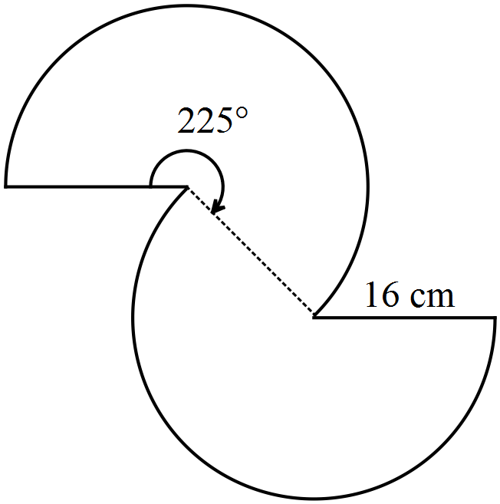

(a) Determine the perimeter of the logo. (3 marks)



(b) Determine the area of the logo. (2 marks)



Question 9 (7 marks)

(a) The standard cash fares on a public transport system are related to how many sectors that a user travels through, as shown in the table below.

|  |  |  |  |  |  |  |
| --- | --- | --- | --- | --- | --- | --- |
| Sectors | 1 | 2 | 3 | 4 | 5 | 6 |
| Cash fare | 2.90 | 4.40 | 5.20 | 6.20 | 7.70 | 8.70 |

(i) A user who buys a book of 25 tickets in advance is offered a 15% discount. How much would such a book of tickets cost for 3-sector journeys? (2 marks)



(ii) A user with a TravelCard is entitled to a 25% discount on all fares if the TravelCard is automatically topped up by direct debit. How much does such a user save in a week when they make seven 1-sector journeys, two 2-sector journeys and one 6-sector journey? (2 marks)



(iii) The cash fares include 10% GST. How much GST is included in the 5-sector cash fare? (1 mark)



(b) The exchange rate at an airport currency exchange office is 9455 Indonesian Rupiah for one Australian Dollar. The office also charge a conversion fee of 6.5% on all amounts exchanged. Determine the cost of buying 2 880 000 Indonesian Rupiah at this office in Australian dollars, giving your answer to the nearest cent. (2 marks)



Question 10 (8 marks)

A person who qualifies for a particular government pension will be paid $776.70 per fortnight, so long as they do not earn more than $160 in that time. In any fortnight that they do earn more than $160, their pension will be reduced by 50 cents in the dollar for earnings over $160.

(a) A man who qualifies for this pension starts a part time job for 18 hours per week that pays $15.25 per hour.

(i) Calculate the fortnightly earnings of the man. (1 mark)



(ii) By how much will his fortnightly pension be reduced? (2 marks)



(iii) Determine the fortnightly sum of his job earnings and pension. (1 mark)



(b) A woman who qualifies for this pension earns $938 each fortnight. Calculate the fortnightly pension she receives. (2 marks)



(c) If a qualifying person earns enough in a fortnight, their payment reduces to $0. Determine the minimum amount a person must earn to reach this cut off point. (2 marks)



Question 11 (9 marks)

The plan on the grid below shows a scale drawing (using a scale of 1:200) of two concrete slabs, . Assume that each small square on the grid measures 2 mm by 2 mm.

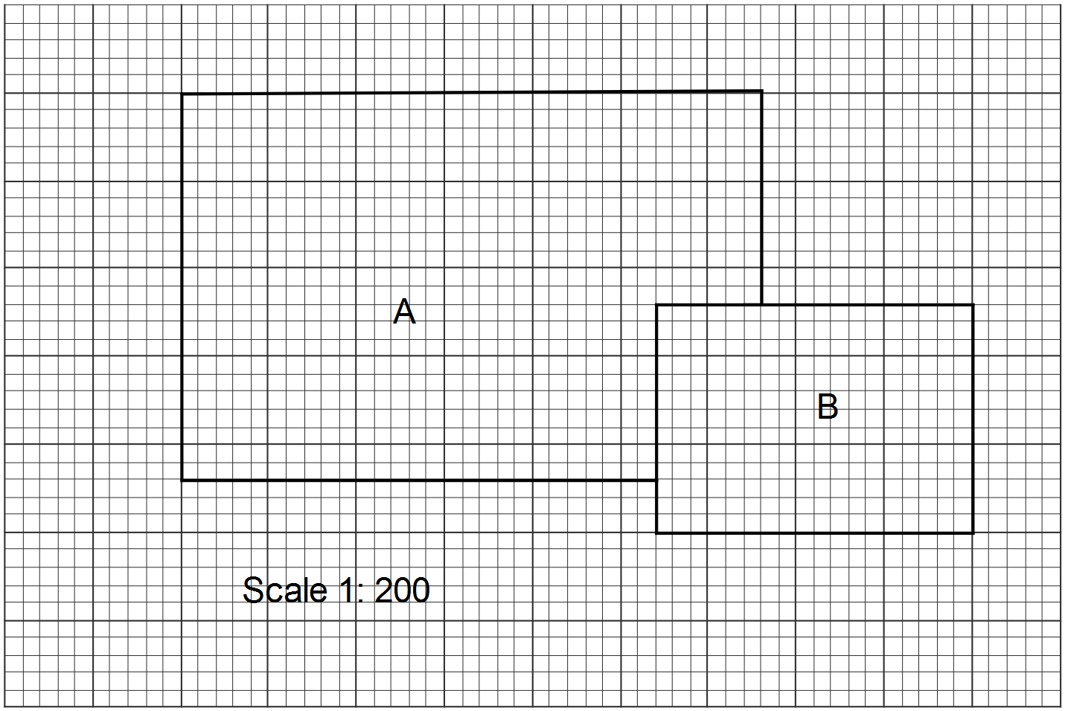

(a) Use the grid to determine the perimeter of slab  on the scale drawing, giving your answer in centimetres. (2 marks)



(b) Show that the actual dimensions of slab  that would be used by a builder setting out the concrete slab on a building site are 7.2 m long by 5.2 m wide. (1 mark)



The builder pours the concrete so that the finished slabs are 22 cm thick.

(c) Determine the volume of concrete required for slab  in cubic metres. (2 marks)



(d) Determine the volume of concrete required for slab  in cubic metres, rounding your answer to one decimal place. (4 marks)



Question 12 (7 marks)

(a) A waiter was employed at an hourly rate of $24.65. Calculate his total earnings in a week when he worked for 35 hours at his regular rate and also worked 6 hours of over-time, for which he was paid time-and-a-half. (2 marks)



(b) A financial planner earns a salary of $85 680 and is paid monthly. At the end of last year she received a bonus equal to 65% of her gross monthly pay. Calculate her total gross pay for that month. (2 marks)



(c) The sales assistants at an electrical retailer are paid a weekly retainer of $725 plus 8% commission on the total value of the goods that they sold during a week.

(i) Calculate the weekly pay for a sales assistant who sold $18 520 worth of appliances during a week. (1 mark)



(ii) Another sales assistant had a weekly pay of $1931. Determine the value of appliances that this person sold. (2 marks)



Question 13 (8 marks)

The table below displays information about three companies listed on the Australian share market in early 2015.

|  |  |  |  |  |  |
| --- | --- | --- | --- | --- | --- |
| ASX Code | Market value of share  ($) | Earnings per share  ($) | Price-to-earnings ratio | Annual dividend  ($) | Percentage dividend  (% pa) |
| AMP | 6.51 | 0.23 | **P** | 0.24 | **Q** |
| BGA | 5.23 | 0.44 | 11.9 | **R** | 1.63 |
| NAB | 37.76 | **S** | 16.9 | 1.99 | 5.27 |

(a) Determine the values of P, Q, R and S in the table above. (4 marks)



(b) An investor held a portfolio consisting of 350 AMP shares, 420 BGA shares and 275 NAB shares. Determine the total market value of this portfolio. (2 marks)



(c) Another investor held a portfolio consisting of 1540 NAB shares and 5390 AMP shares. Determine the total annual dividend paid for this portfolio. (2 marks)



Question 14 (11 marks)

(a) A 4.5 metre long ladder rests on level ground between two buildings with one end, , on the ground and the other end touching point , at a height of 4.25 metres up the wall of one of the buildings. The ladder is then rotated about  so that the other end touches point , 3.6 m up the opposite wall.

(i) Add the above dimensions to the sketch below. (1 mark)

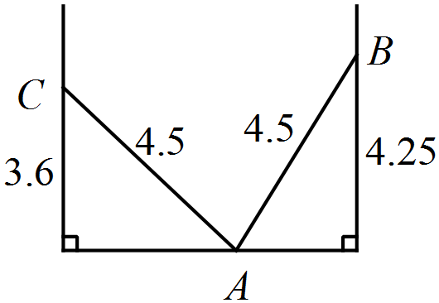

(ii) Determine the horizontal distance between the two buildings, giving your answer correct to two decimal places. (3 marks)



(iii) A length of wire is stretched tightly from  to . Determine the length of this piece of wire. (2 marks)



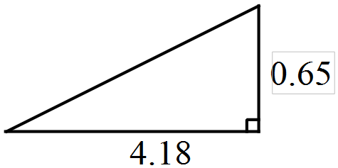

(b) A 22 metre tall radio mast stands vertically on level ground with its base in the middle of a square with sides that are 10 metres long. The mast is supported by four cables, each stretching from a corner of the square to the tip of the mast.

(i) Sketch a diagram of this situation. (1 mark)

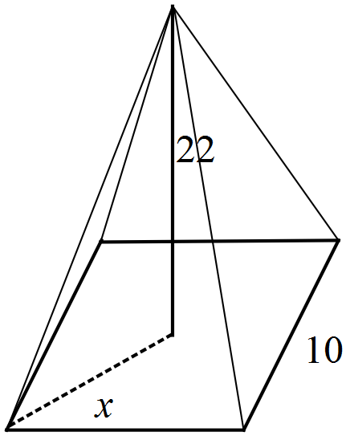

(ii) Determine the length of a diagonal of the square. (1 mark)



(iii) Determine the total length of all four cables required to support the mast. (3 marks)



Question 15 (7 marks)

Monthly mobile phone data plans available from three companies were as follows: 4.5GB of data from Vofo for $45.95; 3.5GB of data from Stratel for $34.90; and 2.5GB of data from Uptop for $29.00.

(a) Rank these three companies in order of best to worst value using the unit cost method.

(3 marks)



Best to worst value order is: Stratel, Vofo and then UpTop.

(b) Vofo wish to decrease the amount of data offered on their plan from 4.5GB to 3.5GB, whilst maintaining the same unit cost. Determine the new price of this plan, rounded to the nearest five cents. (2 marks)

Unit cost is $10.21:



(c) Uptop buy their data for the above plan from another company that charges them $6.55 per GB. Calculate the percentage mark-up on the data cost for their 2.5GB plan. (2 marks)



Question 16 (8 marks)

(a) Calculate the total surface area of the prism shown below that has a rectangular base 7 m by 8.2 m and has a height of 2.4 m. (4 marks)

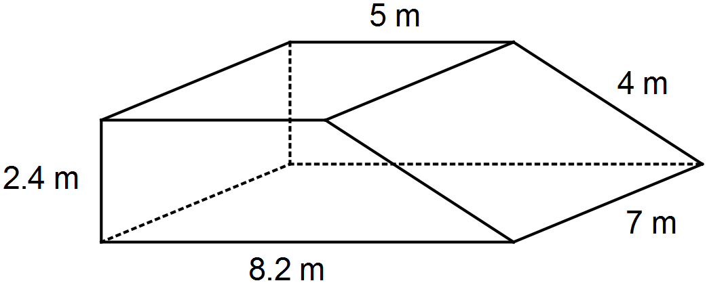



(b) A triangle with sides of lengths 10.5 cm, 11 cm and 12.5 cm has the same perimeter as a square of side length  cm, a rectangle measuring 11.5 cm by  cm and a circle of radius  cm. Determine the values of ,  and . (4 marks)



Question 17 (9 marks)

The number of hours of labour required by each of workers A, B and C during the manufacture of three products P, Q and R is shown in the matrix M below.



(a) Explain the significance of the number in the second row and first column. (1 mark)

The zero means that the manufacture of product P does not involve any labour by worker B.

(b) Due to differing experience, workers A, B and C are paid $16, $20 and $22 per hour respectively. Express this information in the row matrix N that is consistent with the information in matrix M. (1 mark)



(c) Determine the product of matrices M and N, in whatever order is possible, and explain what the resulting matrix S shows. (2 marks)



S shows the labour costs of manufacturing products P,Q and R are $136, $134 and $136 respectively.

A standard production run consists of the manufacture of 3, 1 and 2 of products P, Q and R respectively.

(d) Write down a suitable matrix T so that the product ST will show the total labour cost for a standard production run and determine this total labour cost. (2 marks)



Total labour cost is $814.

(e) During a standard production run, worker B is not available.

To maintain production, worker A takes on an extra four hours for product Q and worker C takes on an extra three hours for product R.

Determine, with justification, the effect this has on the total labour cost for a standard production run. (3 marks)



Decreases the total labour cost by $4.

Question 18 (11 marks)

A solid cone of radius 9 cm and height 12 cm is placed symmetrically atop a solid hemisphere of radius 11 cm to form the composite solid shown below.

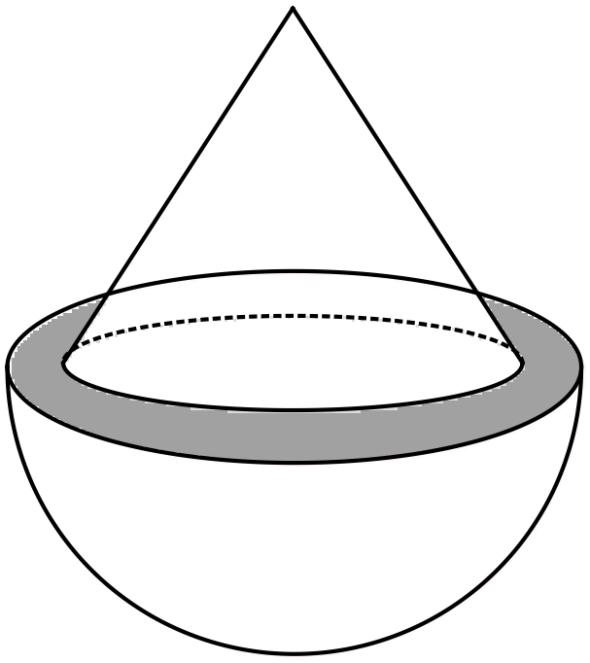

(a) Use Pythagoras' Theorem to calculate the slant height of the cone. (1 mark)



(b) Determine the area of the grey shaded ring, between the cone and the hemisphere, as shown in the diagram above. (2 marks)



(c) Determine the surface area of the composite solid. (3 marks)



(d) Calculate the volume of the composite solid. (3 marks)



(e) A larger composite solid is made with a similar shape to the one above, so that the cone has radius 45 cm and height 60 cm and the solid hemisphere has radius 55 cm.

(i) State the ratio of lengths in the small solid to the large solid in simplified form.

(1 mark)



(ii) Explain how to use the ratio above and the volume calculated in (d) to determine the volume of the larger composite solid. (1 mark)

Multiply the volume in (d) by  (125) to get the new volume.

Question 19 (8 marks)

(a) Over a six-year period, the average rate of inflation was 2.9% pa.

(i) At the start and end of this six year period, the salary of a nurse was $64 540 and $76 445 respectively. Comment, with justification, on how the nurses salary increased over the six years compared to the rate of inflation. (2 marks)



Hence increased just below the rate of inflation.

(ii) If the price of milk increased at this rate of inflation over the six years to $2.20, calculate the price of milk at the start of the six year period. (2 marks)



Price was $1.85

(b) A financial institute has two different types of loan for businesses that borrow amounts up to $75 000. Loan type A charges simple interest on the principal borrowed at a rate of 7.49% each year whilst the loan type B charges 6.79% pa interest compounded monthly.

A business needs to borrow $55 000 to purchase some new equipment. The business will be able to repay the loan and interest in full after 30 months.

Which of the two loans will minimise the amount of interest payable by the business?

Justify your answer. (4 marks)



Loan type B will minimise the interest payable.

Additional working space

Question number: _________

This examination paper may be freely copied, or communicated on an intranet, for non-commercial purposes within educational institutes that have purchased the paper from WA Examination Papers provided that WA Examination Papers is acknowledged as the copyright owner. Teachers within Rossmoyne Senior High School may change the paper provided that WA Examination Paper's moral rights are not infringed.

Copying or communication for any other purposes can only be done within the terms of the Copyright Act or with prior written permission of WA Examination papers.

*Published by WA Examination Papers*

*PO Box 445 Claremont WA 6910*